241901005

EXP NO 1: CAPTURE ALL THE FLAGS IN ENCRYPTION 101
IN TRYHACKME PLATFORM

AIM:
To capture the various flags in Encryption Crypto 101 in TryHackMe platform.

ALGORITHM:
- Access the Encryption Crypto 101 lab in TryHackMe platform.
- Click Start AttackBox to run the instance of Kali Linux distribution.
- Solve the crypto math used in RSA.
- Find out who issued the HTTPS Certificate to tryhackme.com
- Perform SSH Authentication by generating public and private key pair using ssh-keygen
- Perform decryption of the gpg encrypted file and find out the secret word.

OUTPUT: 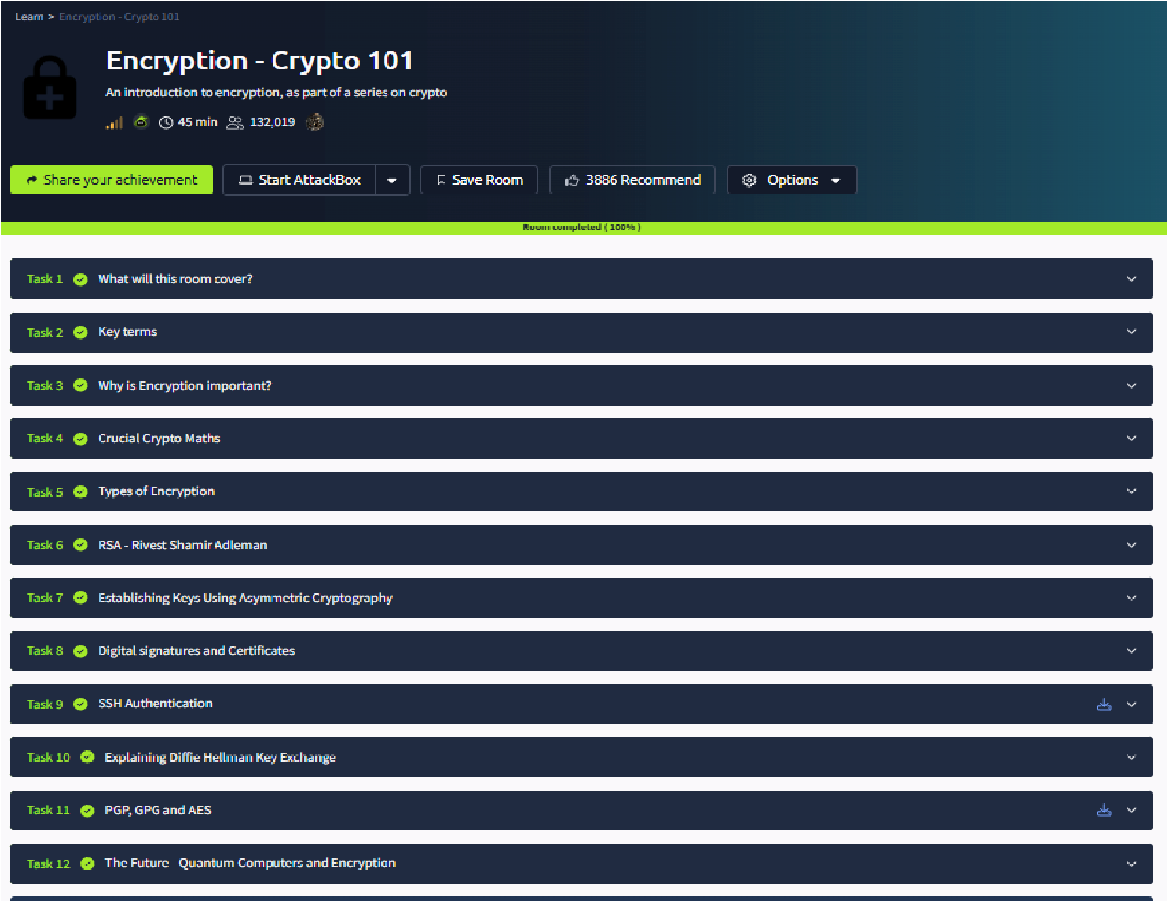

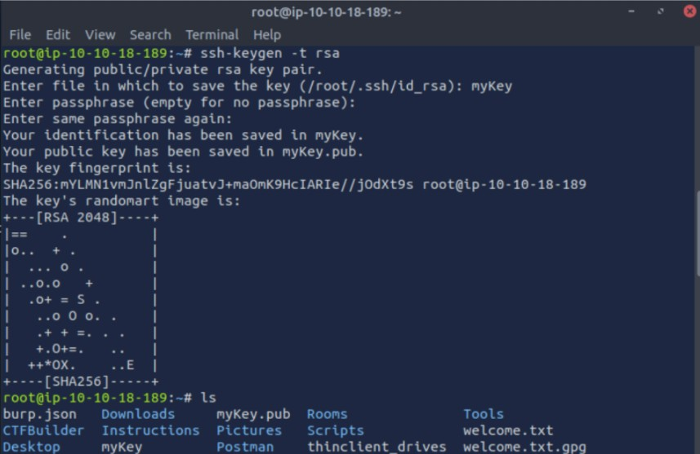

RESULT: Thus, the various flags have been captured in Encryption Crypto 101 in TryHackMe platform.

